List of issues:
- Attempted to multiply an integer by a string (line 4). Identified using breakpoints and PyCharm's debugging mode, which showed that the original code was trying to multiply an integer type variable by a string. Change: type-casted the “price” variable to ensure it is always a float and not a string.
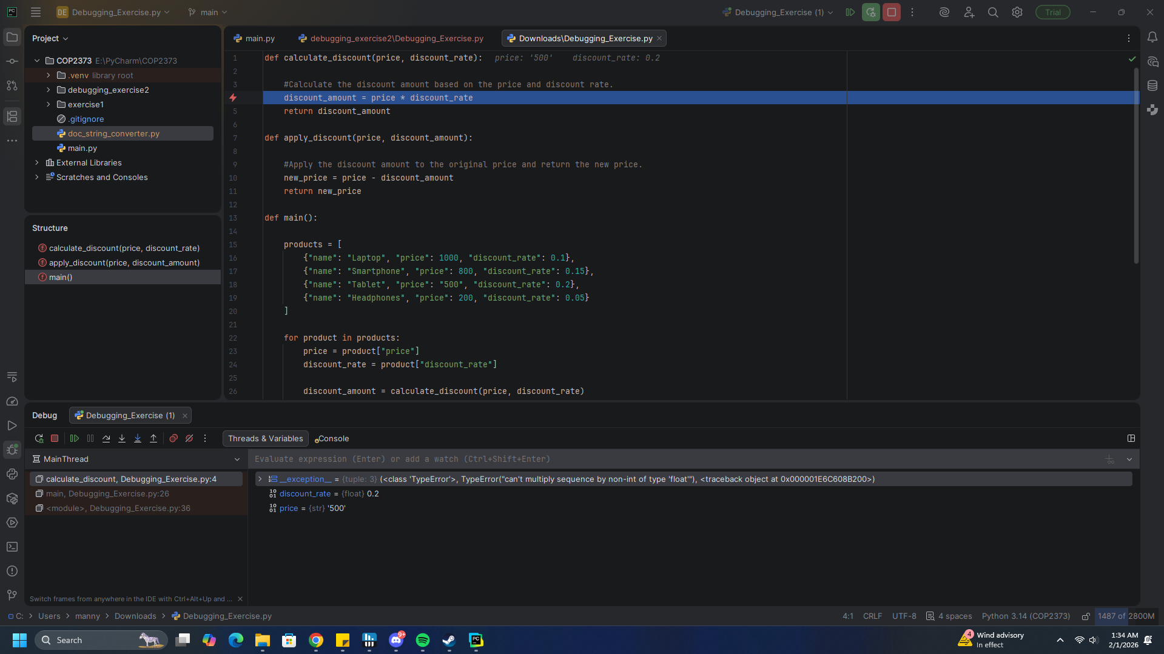

- Attempted to subtract a float from a string (line 10). Identified using breakpoints and PyCharm's debugging mode, which showed that the original code was trying to subtract a float from a string. Change: type-casted the “price” variable to ensure it is always a float and not a string. Solved at the same time as above.

To account for possible empty parts of each list and dict or poor data, added a try-except block.
